

**ADANA ALPARSLAN TÜRKEŞ BİLİM VE TEKNOLOJİ ÜNİVERSİTESİ**

**SOFTWARE ENGINEERING MIDTERM PROJECT**

**HOSPITAL AUTOMATION**

BY :

TOLGA BOROĞLU - Database,Flowchart,Use Case Diagram,Relationalship Database Diagram,UML

BETÜL GÜLER -Word Design,Planning

MELİH MERAL - Programmer,Qt Designer

TUĞBERK HACIOĞLU – Tester,Researcher

YUSUF YANAR - Logo Designer

ELİF SENA EKİZ - Define the functions of the program

**THE GOAL OF THE PROJECT**

The main goal of the software is to meet many needs of Private Atu Hospital and to provide convenience to the user. It is a software to be used in the patient registration department, which can add patients in accordance with hospital requests, make appointments and ensure harmonious work between units.

This software ensures the most effective use of all the resources of the hospital, is managed and monitored by the computer, thus minimizing the loss of time.

**SCOPE :**

Hospital automation provides continuous monitoring of the hospital. The expectation of this service is to provide better quality health care and to ensure that the data is accessible to all health workers.

**AUIDENCE :**

ATU hospital staff, patients,doctors.

**COMPONENTS :**

SQLite database was chosen as the database. SQL is a language used to manage and design data. SQL provides data recording, adding and deleting records.

-Sqllite and microsoft sql

Python is an object-oriented, interpretative, unitary and interactive high-level programming language. Simple syntax based on indentations makes the language easy to learn and remember.Python was used because coding with python is an easy and flexible language compared to other languages.

-Python : vsiual studio code,pycharm etc.

**UML CLASS :**

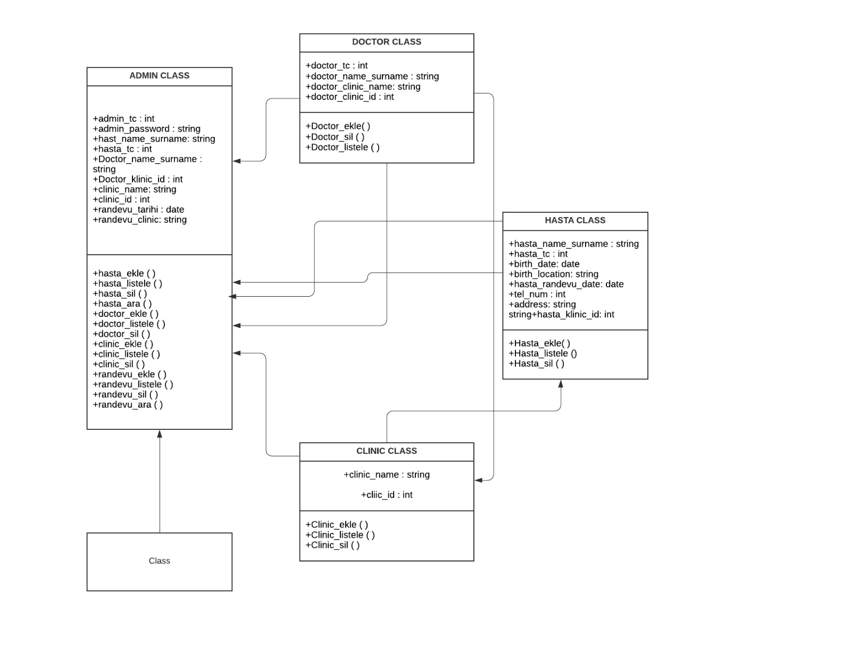

**FLOW CHART :**

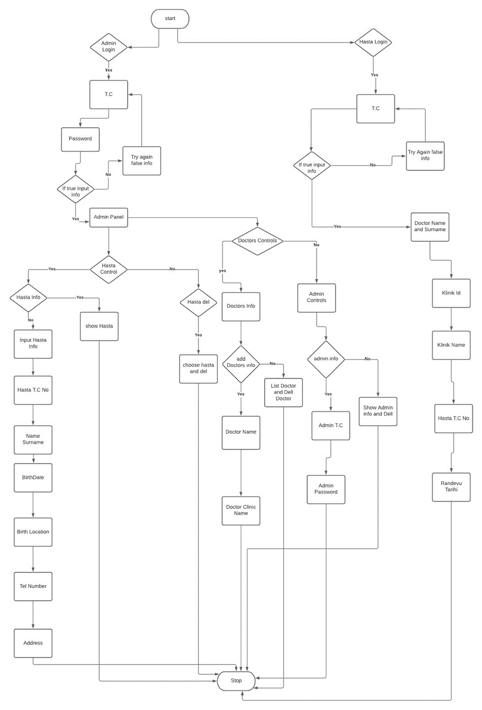

**USE CASE DIAGRAM :**

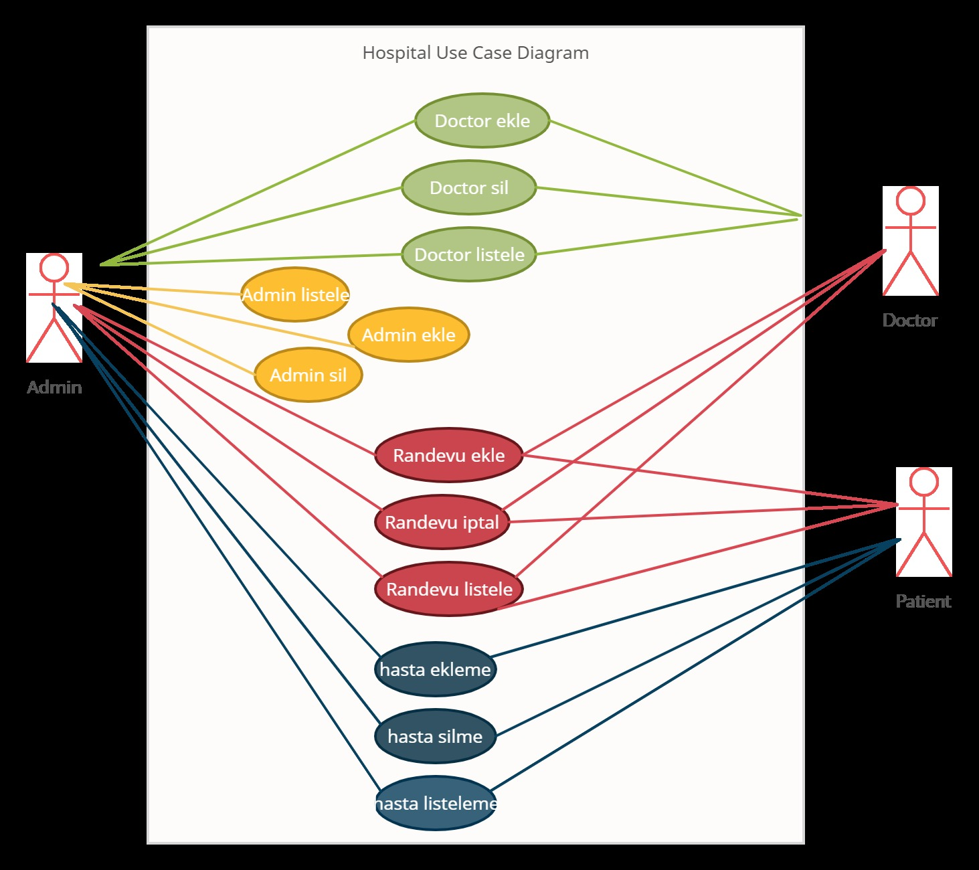

**FUNCTIONS :**

def AdminPanel():  
 Admin_ID = int(input("Enter Your ID: "))  
 Admin_Password = str(input("Enter Your Password: "))  
 if Admin_ID == 12345678910 and Admin_Password == "admin":  
 print("Welcome To The Admin Panel")  
 chooise()  
 else:  
 print("Try Again False Info")  
 AdminPanel()  
  
def chooise():  
 panel= (int(input("Enter 1 for patient control\n Enter 2 for doctors control: ")))  
  
 while panel==1:  
  
  
  
 hasta_info= int(input("Enter 1 for patient info\n Enter 2 for delete patient "))  
 if hasta_info==1:  
 patients()  
 if hasta_info==2:  
 delete_patient()  
 while panel==2:  
 doctorControl()  
def patients(tc="None", name="None", surname= "None", birth_date= "None", birth_place= "None", tel_number="None",address="None"):  
 choose2=int(input("Enter 1 show patients \n Enter 2 add patients: "))  
 if choose2==2:  
 tc=input("Enter Your Tc: ")  
 name=input("Enter Your name: ")  
 surname=input("Enter Your Surname ")  
 birth_date=input("Enter Your birth_date: ")  
 birth_place=input("Enter your tel number: ")  
 address=input("Enter your address: ")  
 print("process successfully")  
 print(tc)  
 print(name)  
 print(surname)  
 print(birth_date)  
 print(birth_place)  
 print(address)  
 cikis()  
 elif choose2==1:  
 show_patient()  
  
def show_patient():  
 patient1 = {"Sıra": 1, "TC": 12345678910, "NAME": "Tolga", "SURNAME": "Boroğlu", "BIRTH_DATE": 1998_1_15,  
 "BIRTH_PLACE": "Mersin", "TEL_NUMBER": 5530008741, "ADDRESS": "Tarsus yenice mahallesi"}  
 patient2 = {"Sıra": 2, "TC": 12345678911, "NAME": "Melih", "SURNAME": "Meral", "BIRTH_DATE": 1999_06_12,  
 "BIRTH_PLACE": "Bursa", "TEL_NUMBER": 5530007741, "ADDRESS": "Adana seyhan duygu cafe"}  
 patient3 = {"Sıra": 3, "TC": 12345678912, "NAME": "Betül", "SURNAME": "Güler", "BIRTH_DATE": 1999_10_31,  
 "BIRTH_PLACE": "Adana", "TEL_NUMBER": 5530007742, "ADDRESS": "Adana seyhan real avm yanı"}  
 patient4 = {"Sıra": 4, "TC": 12345678913, "NAME": "Tuğberk", "SURNAME": "Hacıoğlu", "BIRTH_DATE": 1999_05_29,  
 "BIRTH_PLACE": "Adana", "TEL_NUMBER": 5530007743, "ADDRESS": "Adana yeni stadyum karşısı"}  
 patient5 = {"Sıra": 5, "TC": 12345678914, "NAME": "Yusuf", "SURNAME": "Yanar", "BIRTH_DATE": 2000_07_19,  
 "BIRTH_PLACE": "Adana", "TEL_NUMBER": 5530007744, "ADDRESS": "Adana turgut özal bulvarı"}  
 patient6 = {"Sıra": 6, "TC": 12345678915, "NAME": "Elif Sena", "SURNAME": "Ekiz", "BIRTH_DATE": 1998_3_28,  
 "BIRTH_PLACE": "Adana", "TEL_NUMBER": 5530007745, "ADDRESS": "Adana ziyapaşa bulvarı"}  
 print(patient1.items())  
 print(patient2.items())  
 print(patient3.items())  
 print(patient4.items())  
 print(patient5.items())  
 print(patient6.items())  
 cikis()  
  
def delete_patient():  
 patient1 ={"Sıra": 1, "TC": 12345678910, "NAME": "Tolga", "SURNAME": "Boroğlu","BIRTH_DATE": 1998_1_15, "BIRTH_PLACE": "Mersin", "TEL_NUMBER": 5530008741,"ADDRESS": "Tarsus yenice mahallesi"}  
 patient2={"Sıra":2,"TC": 12345678911, "NAME": "Melih", "SURNAME":"Meral","BIRTH_DATE": 1999_06_12,"BIRTH_PLACE":"Bursa","TEL_NUMBER": 5530007741, "ADDRESS":"Adana seyhan duygu cafe"}  
 patient3={"Sıra":3,"TC":12345678912,"NAME":"Betül","SURNAME":"Güler","BIRTH_DATE": 1999_10_31,"BIRTH_PLACE": "Adana","TEL_NUMBER":5530007742,"ADDRESS":"Adana seyhan real avm yanı"}  
 patient4={"Sıra":4,"TC": 12345678913,"NAME":"Tuğberk","SURNAME":"Hacıoğlu","BIRTH_DATE":1999_05_29,"BIRTH_PLACE": "Adana", "TEL_NUMBER": 5530007743, "ADDRESS": "Adana yeni stadyum karşısı"}  
 patient5={"Sıra":5,"TC": 12345678914, "NAME": "Yusuf","SURNAME": "Yanar", "BIRTH_DATE":2000_07_19,"BIRTH_PLACE": "Adana", "TEL_NUMBER":5530007744,"ADDRESS": "Adana turgut özal bulvarı"}  
 patient6={"Sıra":6,"TC": 12345678915, "NAME":"Elif Sena", "SURNAME": "Ekiz", "BIRTH_DATE": 1998_3_28, "BIRTH_PLACE": "Adana", "TEL_NUMBER": 5530007745, "ADDRESS":"Adana ziyapaşa bulvarı"}  
 print(patient1.items())  
 print(patient2.items())  
 print(patient3.items())  
 print(patient4.items())  
 print(patient5.items())  
 print(patient6.items())  
 silinen=(input("Lütfen silmek istediğiniz hastanın sıra numarasını giriniz: "))  
 silinen=int(silinen)  
 p1=patient1["NAME"]  
 p2=patient1["SURNAME"]  
 p3=patient2["NAME"]  
 p4=patient2["SURNAME"]  
 p5=patient3["NAME"]  
 p6=patient3["SURNAME"]  
 p7=patient4["NAME"]  
 p8=patient4["SURNAME"]  
 p9=patient5["NAME"]  
 p10=patient5["SURNAME"]  
 p11=patient6["NAME"]  
 p12=patient6["SURNAME"]  
  
 if silinen==1:  
 print(f"{p1} {p2} kayıt listesinden silindi")  
 del patient1  
 cikis()  
 elif silinen==2:  
 print(f"{p3} {p4} has been deleted")  
 del patient2  
 cikis()  
 elif silinen==3:  
 print(f"{p5} {p6} has been deleted")  
 cikis()  
 elif silinen==4:  
 print(f"{p7} {p8} has been deleted ")  
 cikis()  
 elif silinen==5:  
 print(f"{p9} {p10} has been deleted ")  
 cikis()  
 elif silinen==6:  
 print(f"{p11} {p12} has been deleted")  
 cikis()  
 else:  
 print("Incorrect selection.Please try again")  
 delete_patient()  
  
  
  
  
  
def doctorControl():  
 info= int(input("Enter 1 for Doctors Info\n Enter 2 for Admin Clinic Controls: "))  
 if info==1:  
 dr_ekle=int(input("Enter 1 for Add Doctors Info\n Enter 2 for list doctor and dell doctor: "))  
 if dr_ekle==1:  
 drkayit()  
 elif dr_ekle==2:  
 admininfo()  
 if info==2:  
 admininfo()  
  
  
def drkayit():  
 dr_name= str(input("Please enter doctor name: "))  
 dr_surname=str(input("Please enter doctor surname: "))  
 clinic_name=str(input("Please enter doctor clinic name: "))  
 print("process successfully")  
 print(dr_name+ " " + dr_surname+ " " + clinic_name)  
 cikis()  
  
def drlist():  
 DR1={"NAME":"PROF DR BETÜL", "SURNAME":"GÜLER","CLINIC":"ÇOCUK SAĞLIĞI"}  
 DR2={"NAME": "DR MELİH","SURNAME":"MERAL", "CLINIC":"GENEL CERRAHİ"}  
 DR3={"NAME": "UZMAN DR YUSUF", "SURNAME":"YANAR", "CLINIC": "KULAK BURUN BOĞAZ"}  
 DR4={"NAME": "PROF DR ELİF SENA", "SURNAME": "EKİZ", "CLINIC": "KADIN HASTALIKLARI"}  
 DR5={"NAME": "DR TOLGA","SURNAME":"CAN","CLINIC":"KULAK BURUN BOĞAZ"}  
 print(DR1)  
 print(DR2)  
 print(DR3)  
 print(DR4)  
 print(DR5)  
 dr_delete= print("Enter 1 for remove doctor: ")  
 if dr_delete==1:  
 delete_dr=str(input("Please enter name and surname of the doctor you want to delete: "))  
 if delete_dr=="Elif Sena Ekiz":  
 print(" PROF DR ELİF SENA EKİZ has been deleted")  
 del DR4  
 if delete_dr=="Betül Güler":  
 print("PROF DR BETÜL GÜLER has been deleted")  
 del DR1  
 if delete_dr=="Yusuf Yanar":  
 print("DR YUSUF YANAR has been deleted")  
 del DR3  
 if delete_dr=="Melih Meral":  
 print("DR MELİH MERAL has been deleted")  
 del DR2  
 if delete_dr=="Tolga Can":  
 print("DR TOLGA CAN has been deleted")  
 else:  
 print("This doctor has not been found.Please Try Again")  
 drlist()  
def admininfo():  
 choose3=int(input("Please enter 1 for add admin\n enter 2 for show admin \n enter 3 for dell admin \n enter 4 for clinic info: "))  
 if choose3==1:  
 yeni_admin= int(input("Please enter tc: "))  
 admin_password=int(input("Please enter password: "))  
 print("process successfully")  
 if choose3==2:  
 admin_info= {"AdminId":"12345678910", "AdminPassword":"admin"}  
 print(admin_info)  
 cikis()  
  
 if choose3==3:  
 admin_info = {"AdminId": "12345678910", "AdminPassword": "admin"}  
  
 print(f"{admin_info} has been deleted")  
 del admin_info  
 cikis()  
  
  
 elif choose3==4:  
 clinic_info()  
 else:  
 print("Incorrect selection.Please try again")  
 admininfo()  
  
def clinic_info():  
 choose4=int(input("Please enter 1 for add clinic \n enter 2 for show clinic \n enter 3 for dell clinic: "))  
 if choose4==1:  
 clinicname=str(input("Please enter name of new clinic: "))  
 print=(f"{clinicname} has been recorded")  
  
 if choose4==2:  
 clinic_list = ["KBB", "KADIN HASTALIKLARI", "GENEL CERRAHİ", "ÇOCUK SAĞLIĞI"]  
 print = (clinic_list)  
  
 elif choose4==3:  
 clinic_list = ["KBB", "KADIN HASTALIKLARI", "GENEL CERRAHİ", "ÇOCUK SAĞLIĞI"]  
 print = (clinic_list)  
 silinen=str(input("Please enter name of the clinic you want to delete: "))  
 silinen= silinen.upper()  
 if silinen=="KBB":  
 clinic_list.remove("KBB")  
 print=("process successfully")  
 print= (clinic_list)  
 elif silinen=="KADIN HASTALIKLARI":  
 clinic_list.remove("KADIN HASTALIKLARI")  
 print=("process successfully")  
 print=(clinic_list)  
 elif silinen=="GENEL CERRAHİ":  
 clinic_list.remove("GENEL CERRAHİ")  
 print=("process successfully")  
 print=(clinic_list)  
 elif silinen=="ÇOCUK SAĞLIĞI":  
 print=("process successfully")  
 print=(clinic_list)  
 else:  
 print=("Incorrect selection.Please try again")  
 clinic_info()  
def cikis():  
 cikis=int(input("If you want to quit please enter 1: "))  
 if cikis==1:  
 exit()  
 else:  
 AdminPanel()  
  
AdminPanel()

**AUTOMATION PICTURES :**

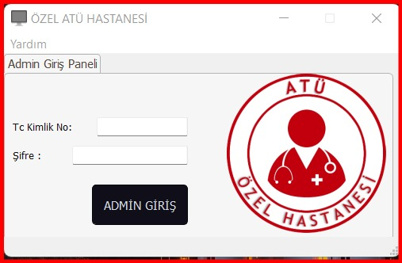

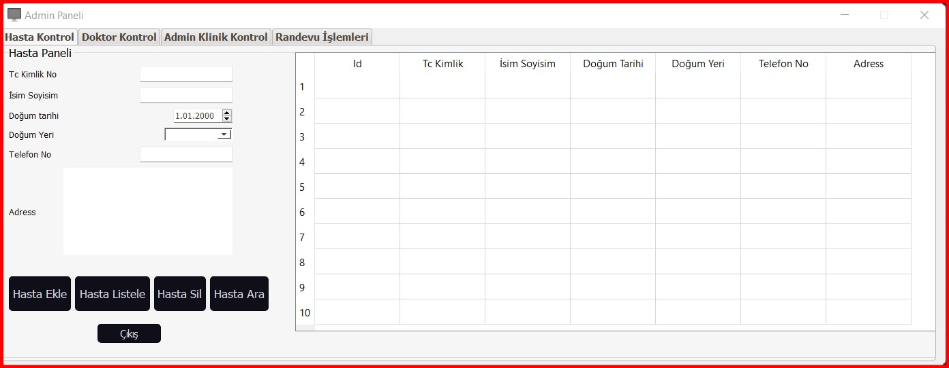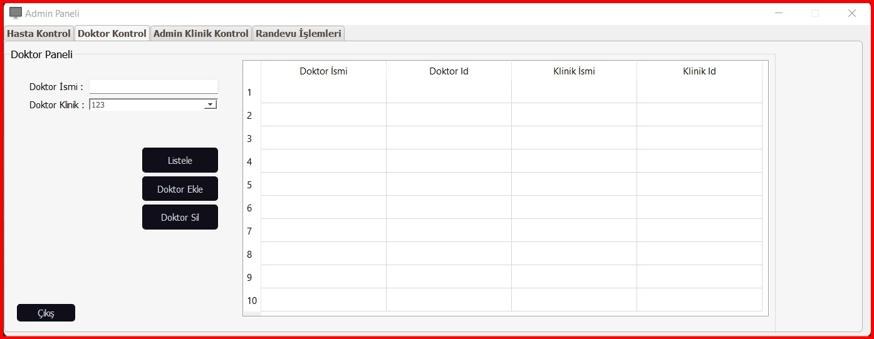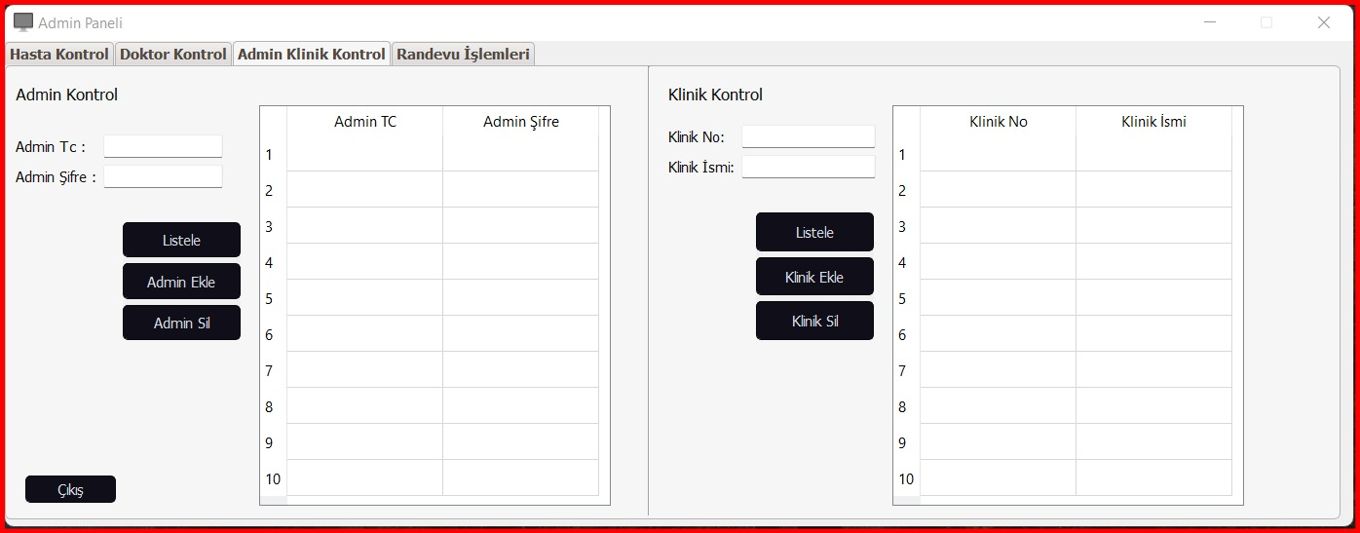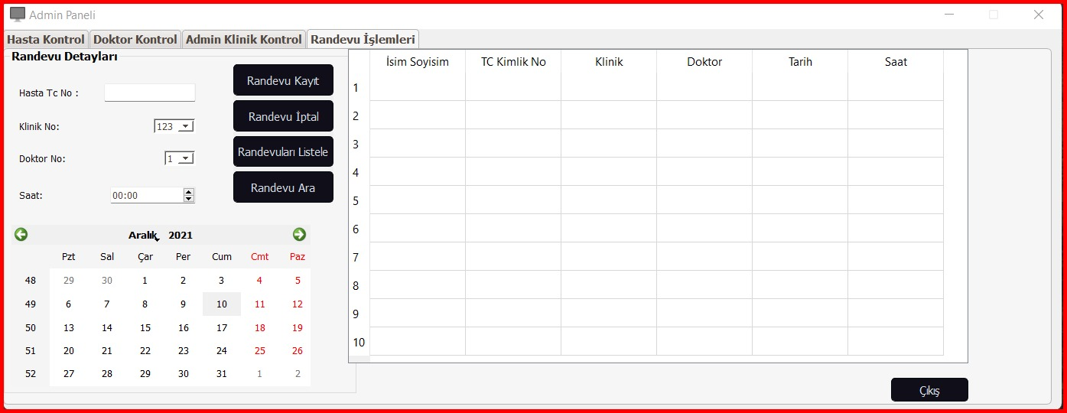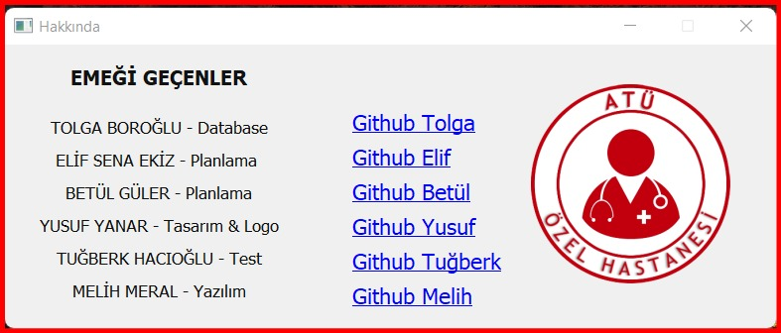

**SOURCES**

<https://doc.qt.io/qtforpython/index.html>

<https://docs.python.org/3.5/>

<https://www.freeprojectz.com/uml-diagram/hospital-management-system-uml-diagram>

<https://lucid.app/>

<https://www.aimprosoft.com/blog/how-to-develop-a-hospital-management-system/>

**GITHUB**

TOLGA BOROĞLU – <https://github.com/tolgaboroglu>

BETÜL GÜLER – <https://github.com/betulguler>

MELİH MERAL – <https://github.com/melihmerall>

TUĞBERK HACIOĞLU – <https://github.com/tugberkhacioglu>

YUSUF YANAR – <https://github.com/psychopose1>

ELİF SENA EKİZ – <https://github.com/elifsenaekiz>